NayePankh Foundation

Introduction
The Volunteer Management System is a simple Python application developed using Tkinter. It helps organizations manage volunteer information efficiently by providing features such as volunteer registration, data storage, search, deletion, and report generation. The following screenshots demonstrate the working and functionality of the system.

Screenshot 1: Main Application Window
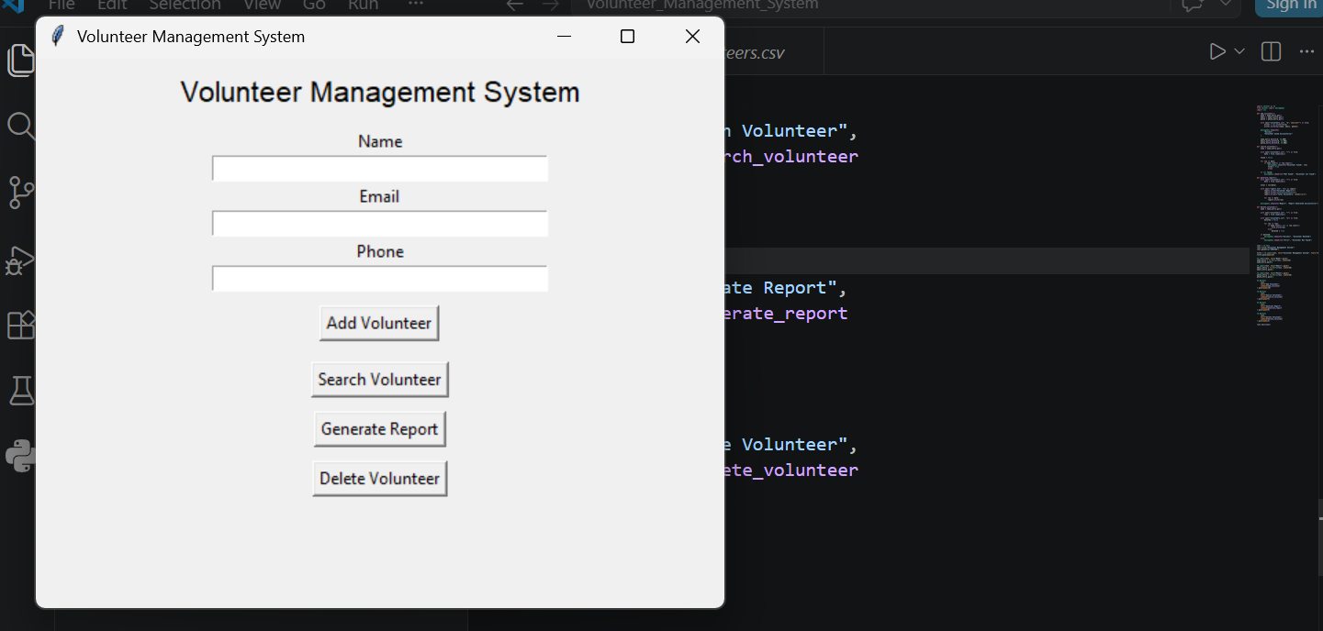
This screenshot shows the main user interface of the Volunteer Management System developed using Python Tkinter. The application provides input fields for entering volunteer details such as name, email address, and phone number.

Screenshot 2: Add Volunteer Feature
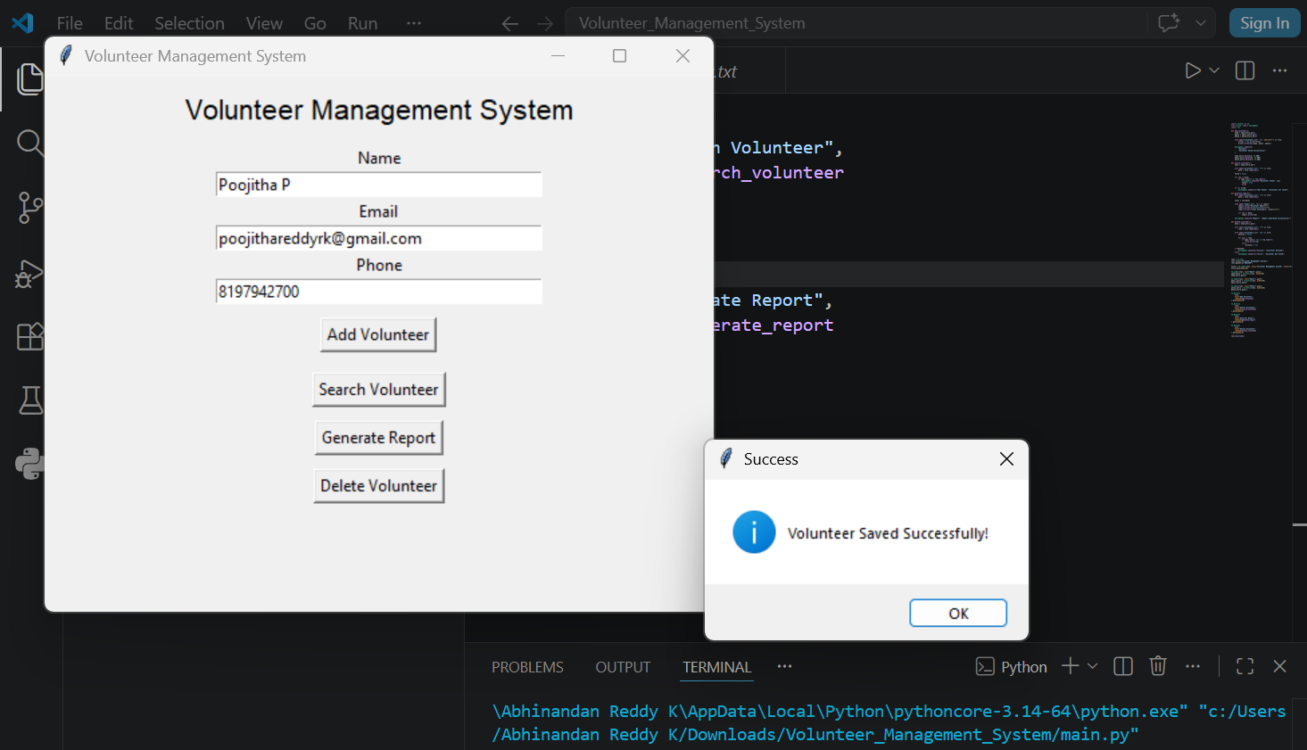
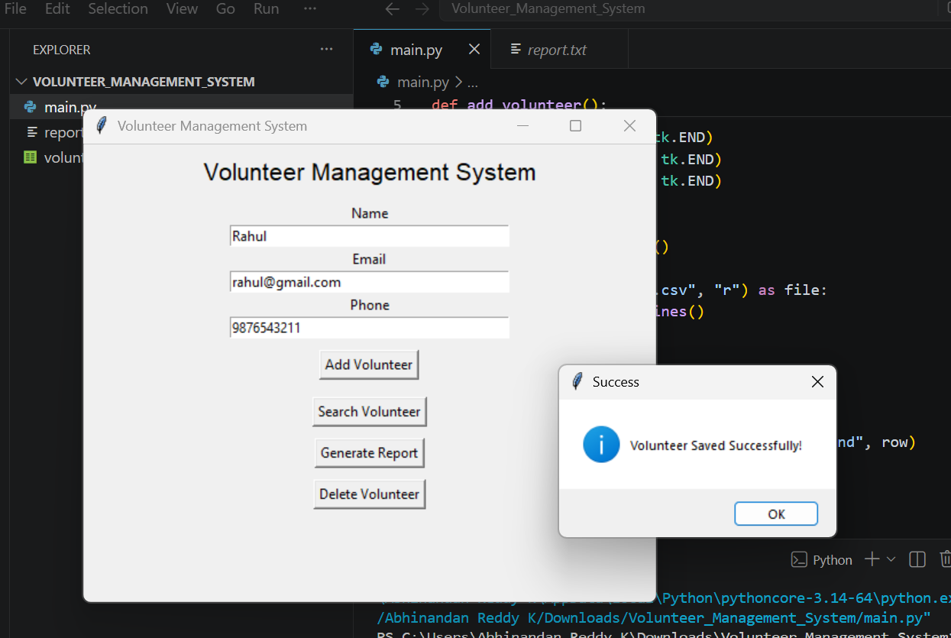 This screenshot demonstrates the Add Volunteer functionality. Users can enter volunteer information and save it into the system. A success message is displayed after the data is stored successfully.

Screenshot 3: Volunteer Data Stored in CSV File
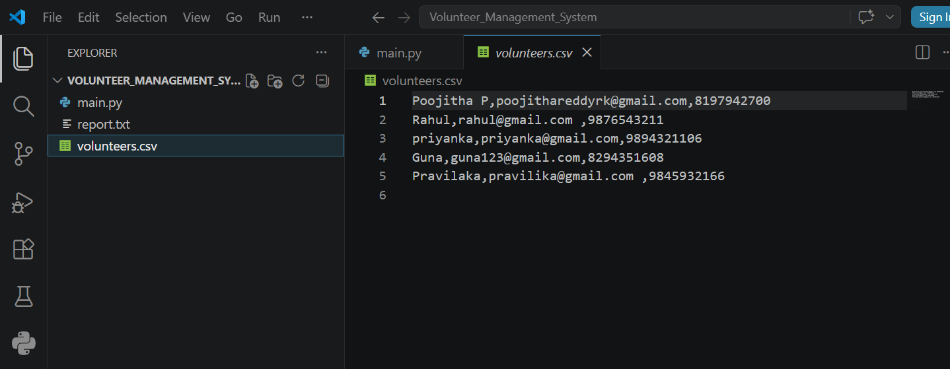
This screenshot shows the volunteers.csv file where volunteer records are stored. The system automatically saves volunteer information, making it easy to manage and access records later.

Screenshot 4: Search Volunteer Feature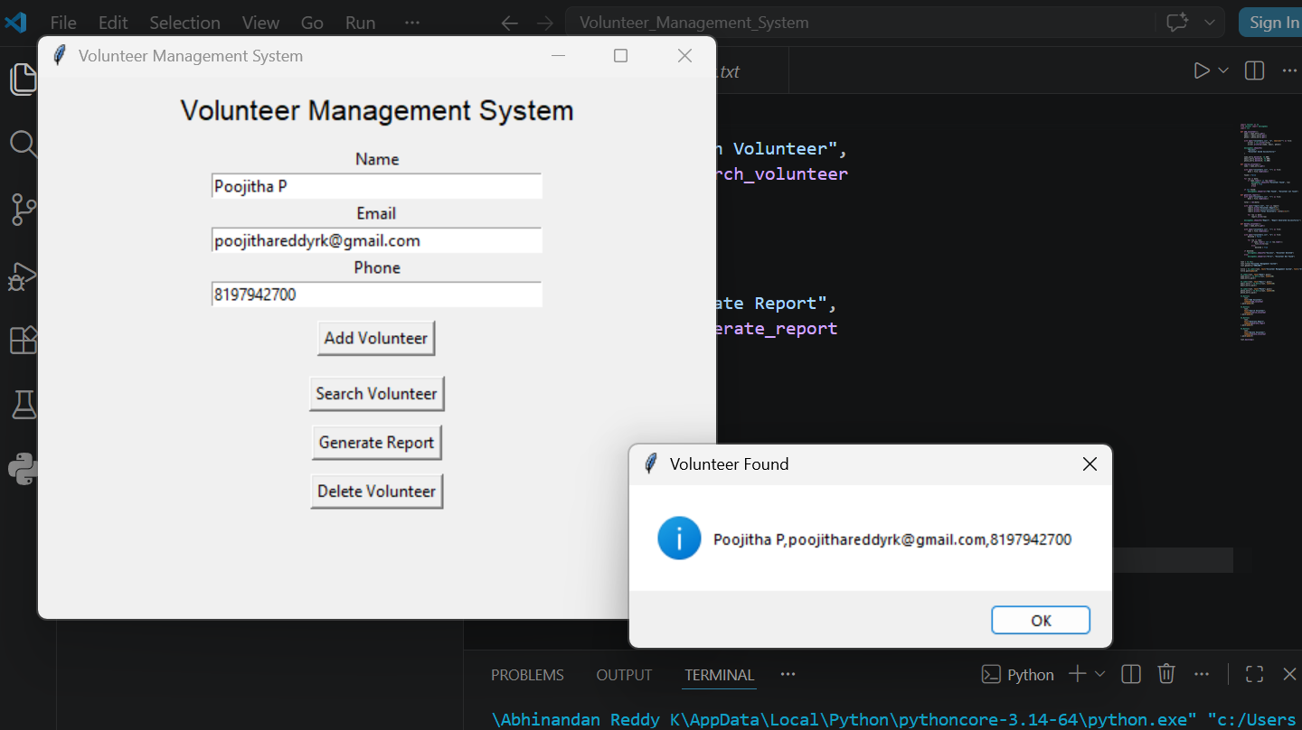
This screenshot demonstrates the search functionality. Users can search for a volunteer by entering the volunteer's name. If the record exists, the system displays the volunteer information.

Screenshot 5: Generate Report Feature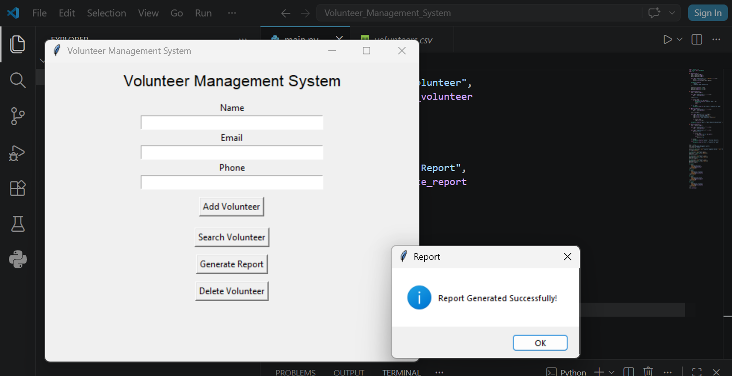
This screenshot shows the report generation functionality. By clicking the Generate Report button, the system creates a report containing volunteer information and a summary of the stored records.
Screenshot 6: Generated Report File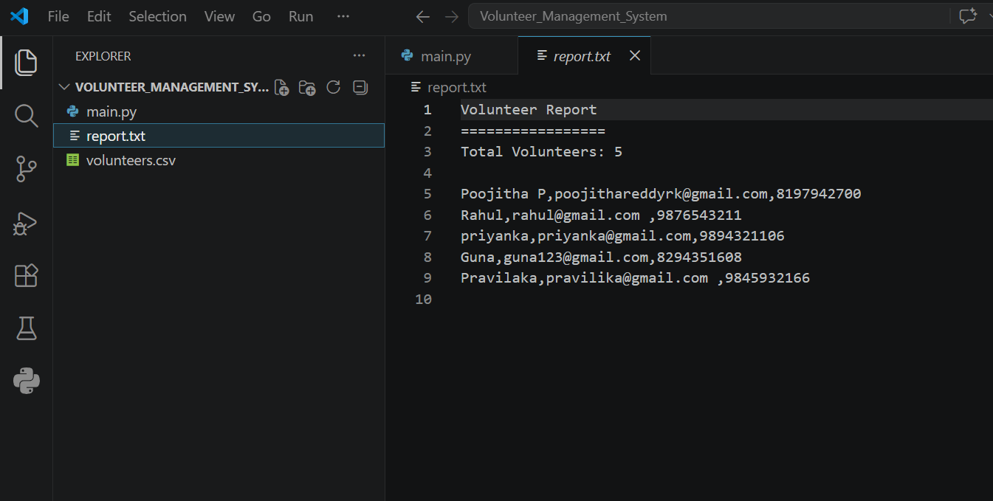
This screenshot displays the generated report.txt file. The report provides details of registered volunteers and helps administrators maintain records efficiently.

Screenshot 7: Delete Volunteer Feature
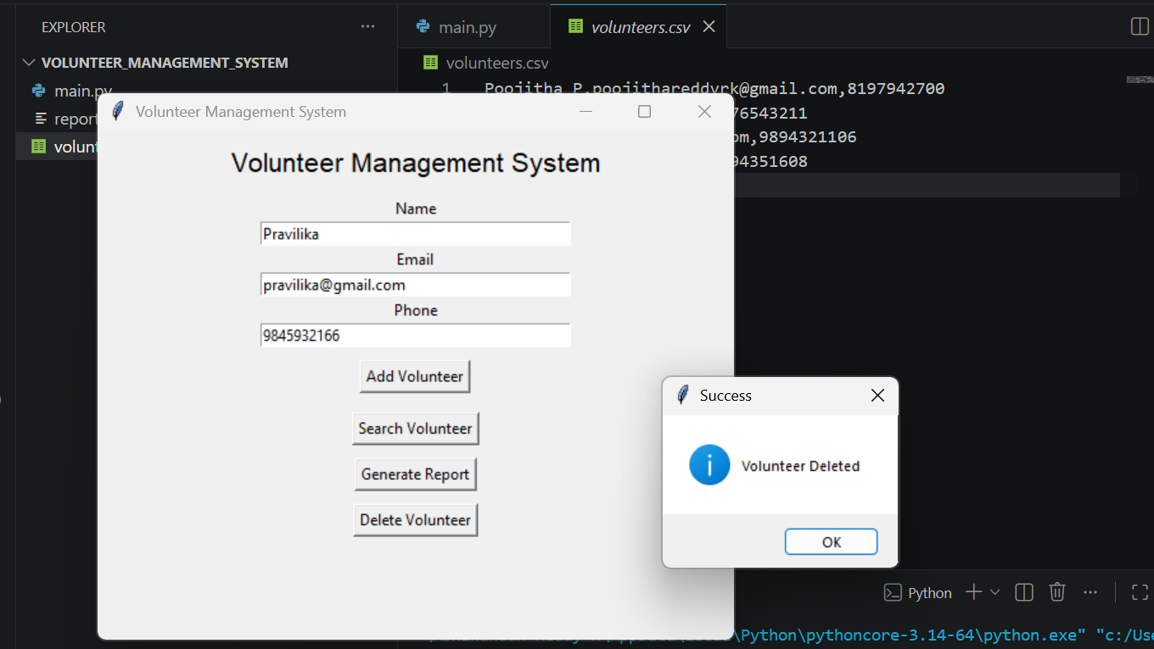
This screenshot demonstrates the delete functionality. Users can remove volunteer records from the system by entering the volunteer name and clicking the Delete Volunteer button.
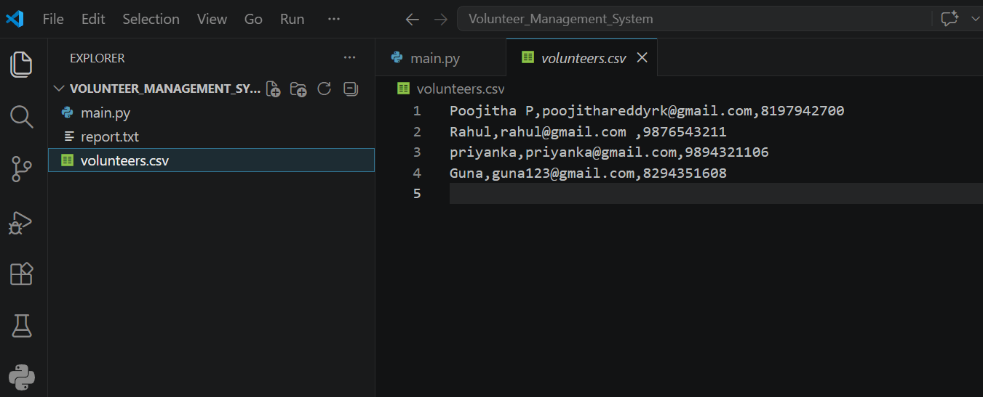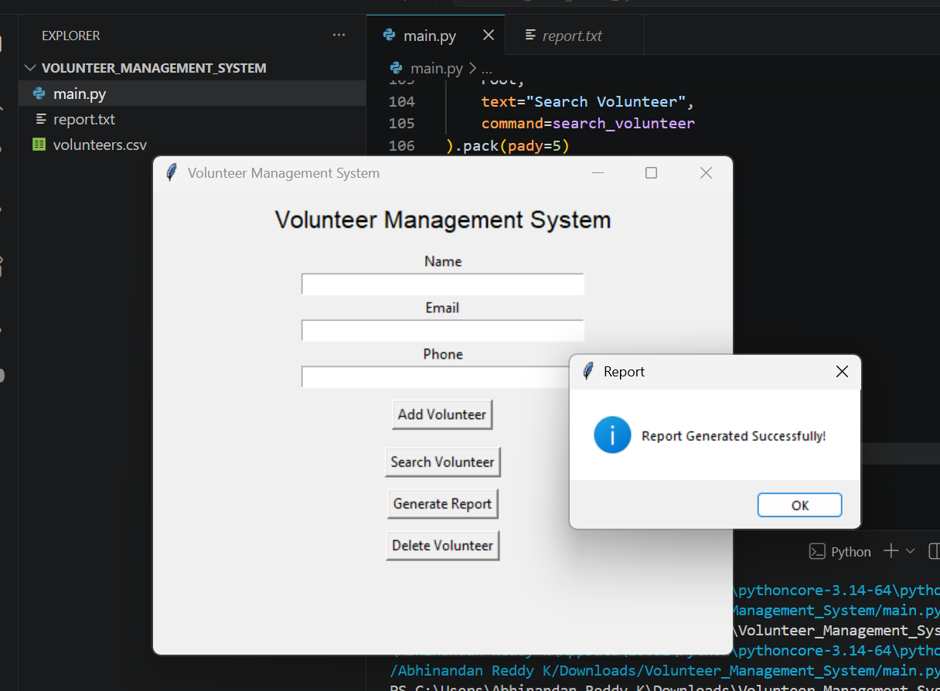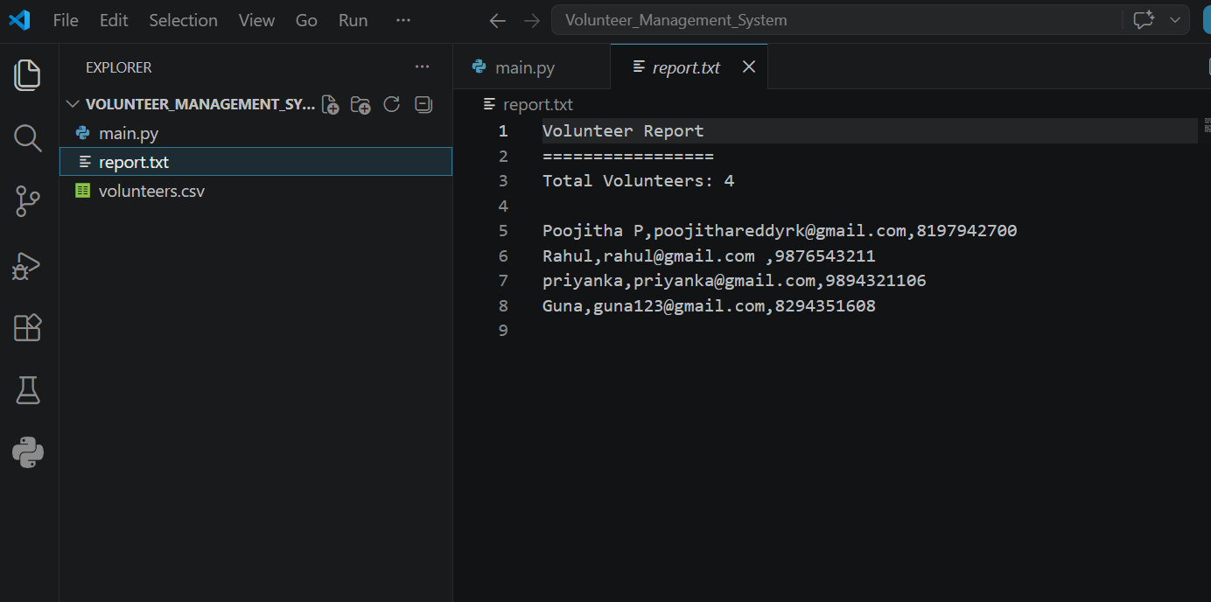

Conclusion
The Volunteer Management System is a Python-based application developed using Tkinter and CSV files. The system allows users to add, search, delete, and manage volunteer information efficiently. It also generates reports automatically, making volunteer record management simple and organized.

